SCUBA-2 Block Specification
lvds_rx

Created on: 30 September 2005
Last saved on: 04 October 2005
Table of Contents

1. Block Description 3
1.1 Block Hierarchy 3
1.1.1 Issue_reply Module 3
1.1.2 Dispatch Module 3
1.2 Block Overview and Features 3
1.3 Detailed Description 4
2. Interface Description 5
2.1 Signals Description 5
2.2 Protocol / Interface Timing 5
3. Dataflow Description 6
4. State Machine Description 7
4.1 Datapath FSM 7
4.2 Interface FSM 8
Source Files 9

Block Description

Block Hierarchy

Issue_reply Module
Cmd_queue
Fibre_rx
Cmd_translator
Lvds_tx
From RTL PC
To Bus Backplane

Reply_queue
Fibre_tx
Reply_translator
Lvds_rx
To RTL PC
From Bus Backplane

Dispatch Module

Dispatch_reply_transmit
Dispatch_cmd_receive
Lvds_rx
Receive_buf
Lvds_tx
Transmit_buf
To Bus Backplane
From Bus Backplane
Dispatch_wishbone

Wishbone
Bus

Block Overview and Features
Lvds_rx implements the receiving end of the communications link over the bus backplane. The bus backplane communications are asynchronous serial and so requires a fast (200 MHz) sampling clock and synchronizers to bring it back into the system clock domain (50 MHz).
This block features:
- 32-bit interface with ready/acknowledge handshaking
- dual-clock FIFO for clock domain crossing
- input synchronizers to synchronize the asynchronous input

Detailed Description
The protocol over the bus backplane is serial, while data is processed in the system primarily in 32-bit units. Therefore, the primary function of lvds_rx is to deserialize the data into a single 32-bit word.
Lvds_rx accepts an input bit from the bus backplane. After passing through a synchronizer, the signal is oversampled by a factor of eight. A majority function is applied to determine the value of the bit in case glitches are present. Finally, the bit is copied to a 32-bit shift register buffer.
After 32 such bits are processed, the complete 32-bit received word is copied into a 16x32-bit dual-clock FIFO data buffer. All of the FIFO’s write logic is in the comm_clk domain, including the datapath FSM. Conversely, all of the FIFO’s read logic is in the clk domain, including the interface FSM. The interface FSM connects with the external modules and implements the ready/acknowledge handshaking mechanism for regulating the data transfer rate.

Interface Description

Signals Description
 | Description | Direction
Global Signals
clk_i | Global 50 MHz clock. | in
comm_clk_i | Global 200 MHz communications clock. Used for sampling the asynchronous input. | in
rst_i | Global reset. | in
Host interface Signals
dat_o | 32-bit received data output. | out
rdy_o | Data ready. Indicates that data on dat_o is valid. | out
ack_i | Data acknowledge. Indicates that the data on dat_o has been latched. | in
LVDS Signals
lvds_i | Asynchronous LVDS input from bus backplane. | in

Interface Timing

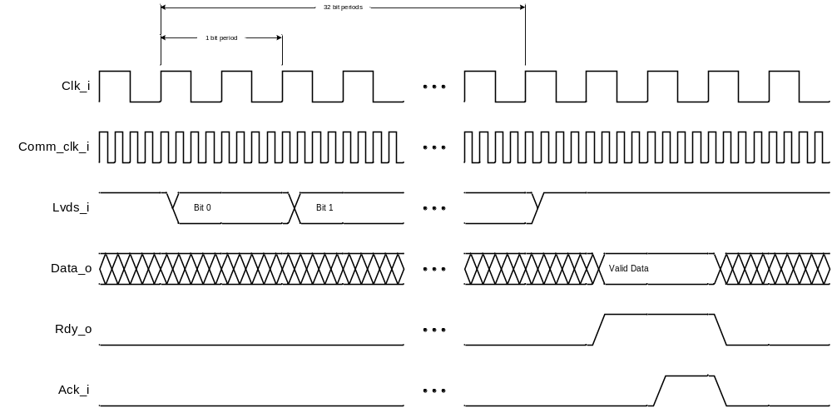

Dataflow Description
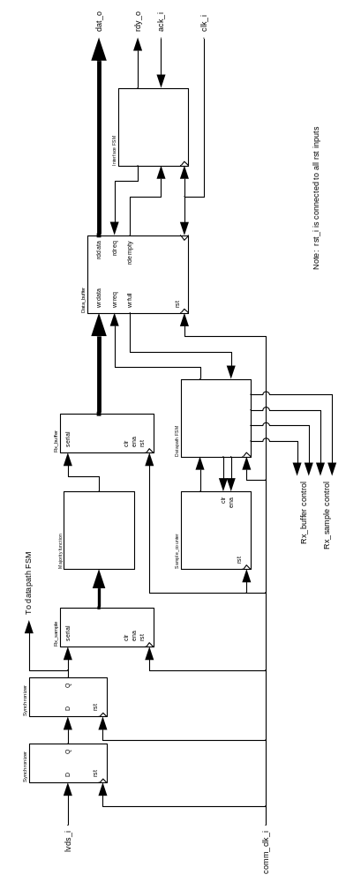

State Machine Description

Datapath FSM
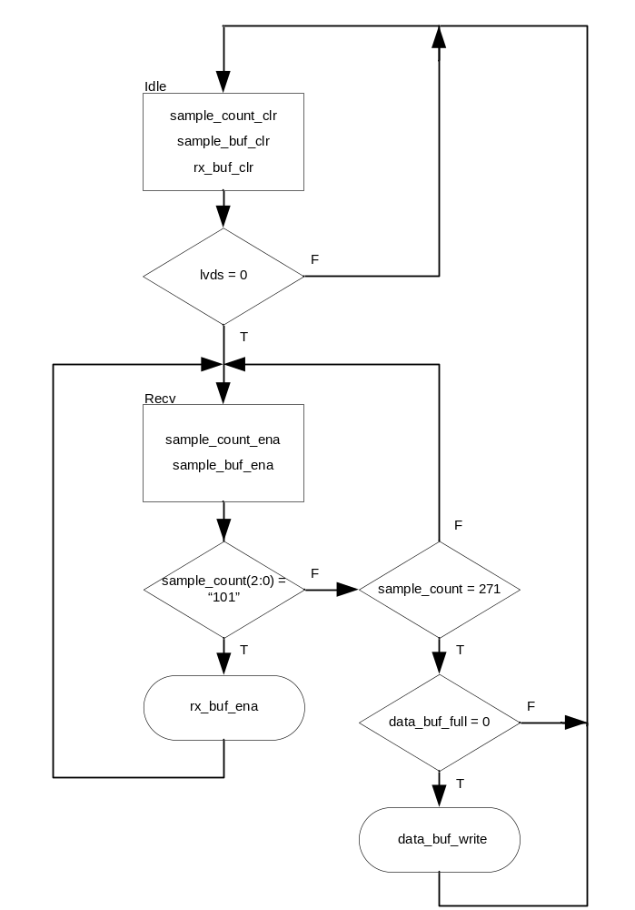

Interface FSM
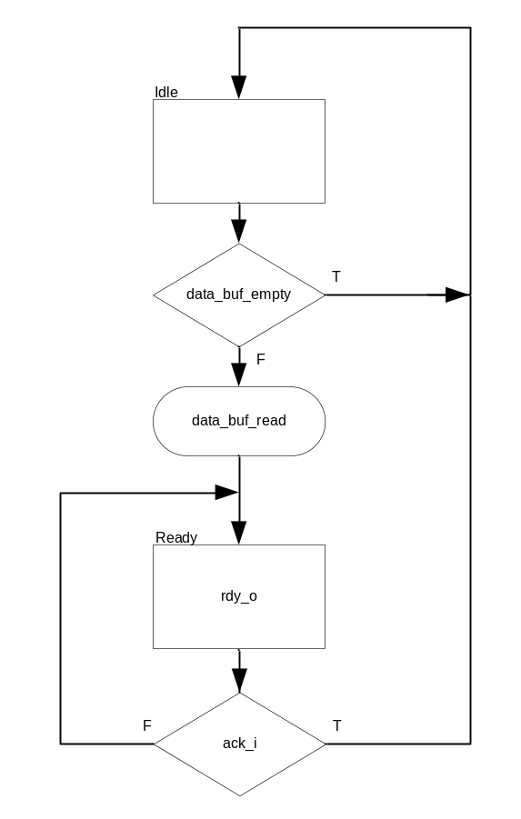

Source Files

File | Description
lvds_rx.vhd | Implementation of the LVDS receiver

